**Name:Omkar Pralhad Gharat.**

**Enrollment No.: 2101950**

**Cloud Computing Practical-5**

**\*\*\*\*\*\*\*\*\*\*\*\*\*\*\*\*\*\*\*\*\*\*\*\*\*\*\*\*\*\*\*\*\*\*\*\*\*\*\*\*\*\*\*\*\*\*\*\*\*\*\*\*\***

**Hosting a static website in AWS using S3.**

**\*\*\*\*\*\*\*\*\*\*\*\*\*\*\*\*\*\*\*\*\*\*\*\*\*\*\*\*\*\*\*\*\*\*\*\*\*\*\*\*\*\*\*\*\*\*\*\*\*\*\*\*\***

**Step-1:** **Login into AWS student Login**

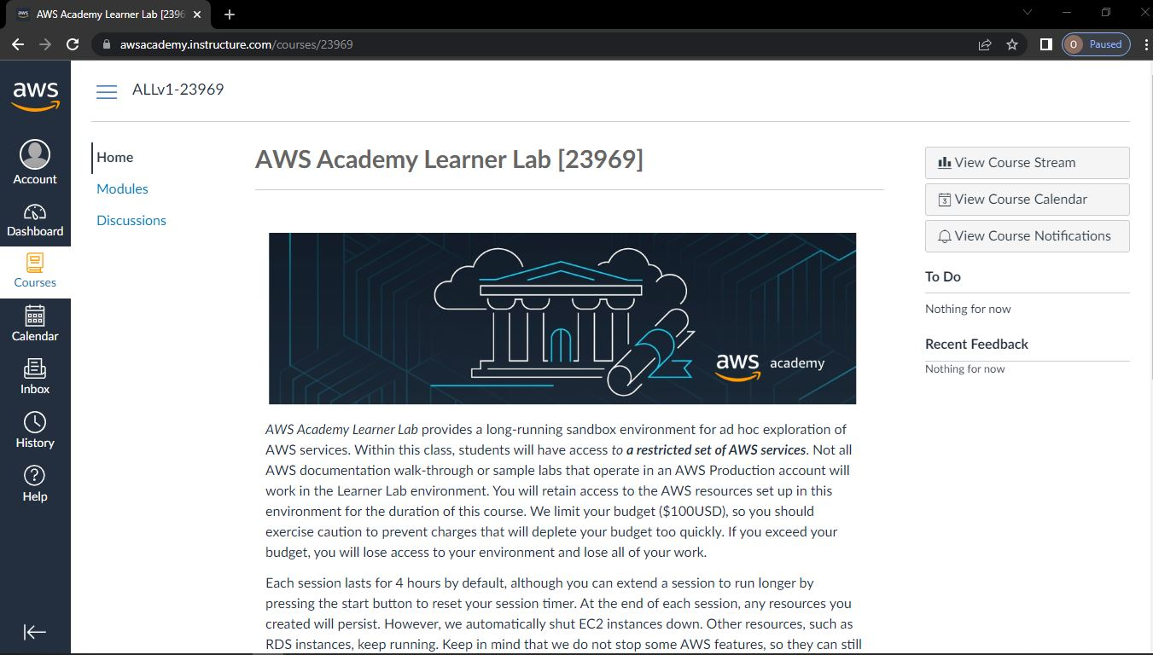

**Step-2: Click on module -> Select Learner Lab -> Click on AWS with indicated green light**

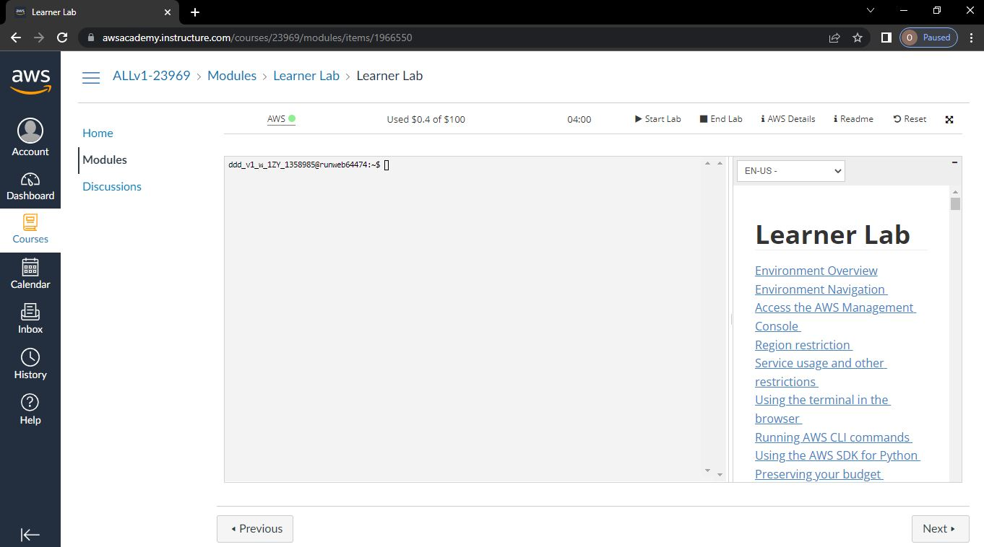

**Step-3: Go to Services -> Below that select Storage-> S3**

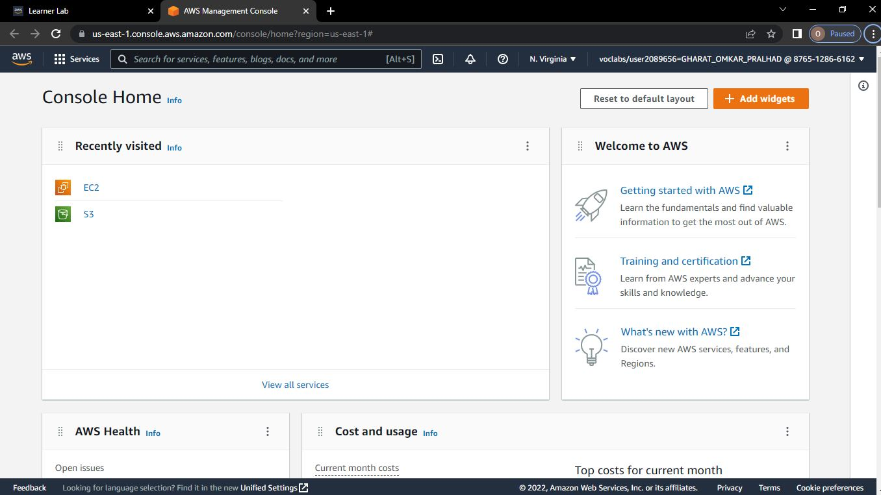

**Step-4: Click on create bucket**

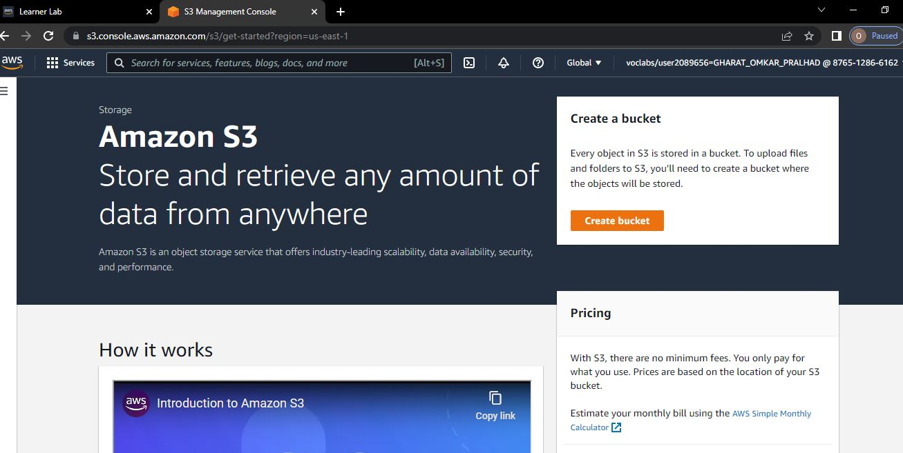

**Step-5: Give any name to Bucket**

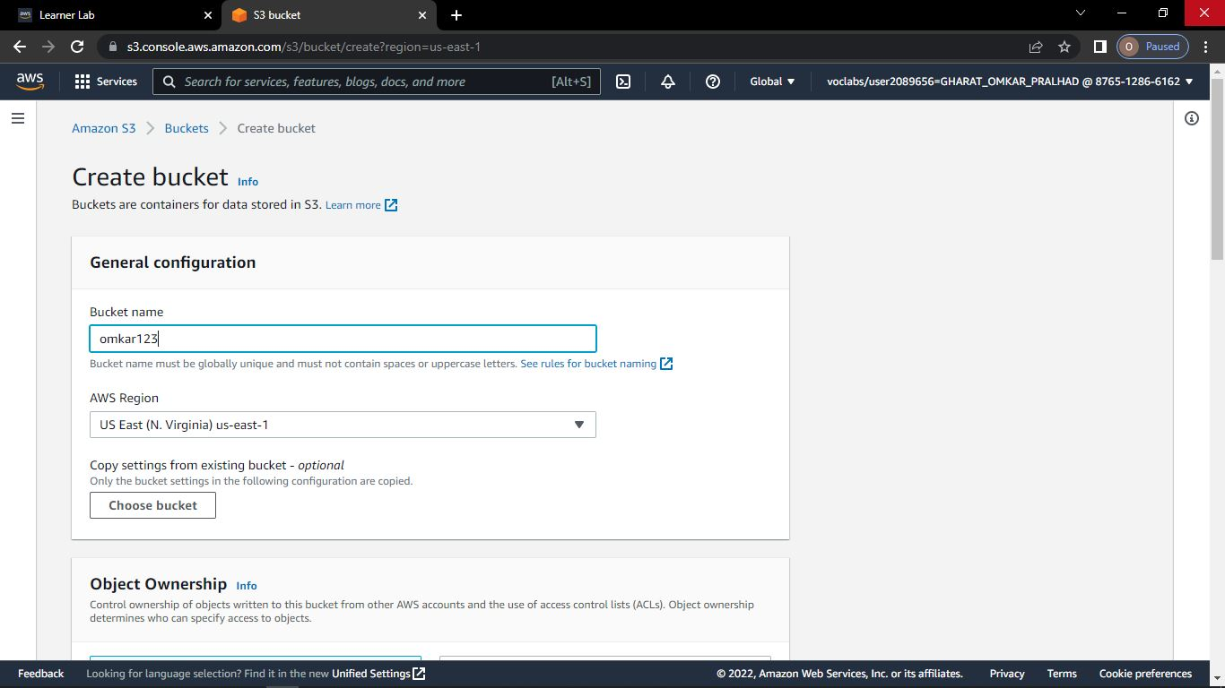

**Step-6: Select ACLs enabled and Click on Create Bucket.**

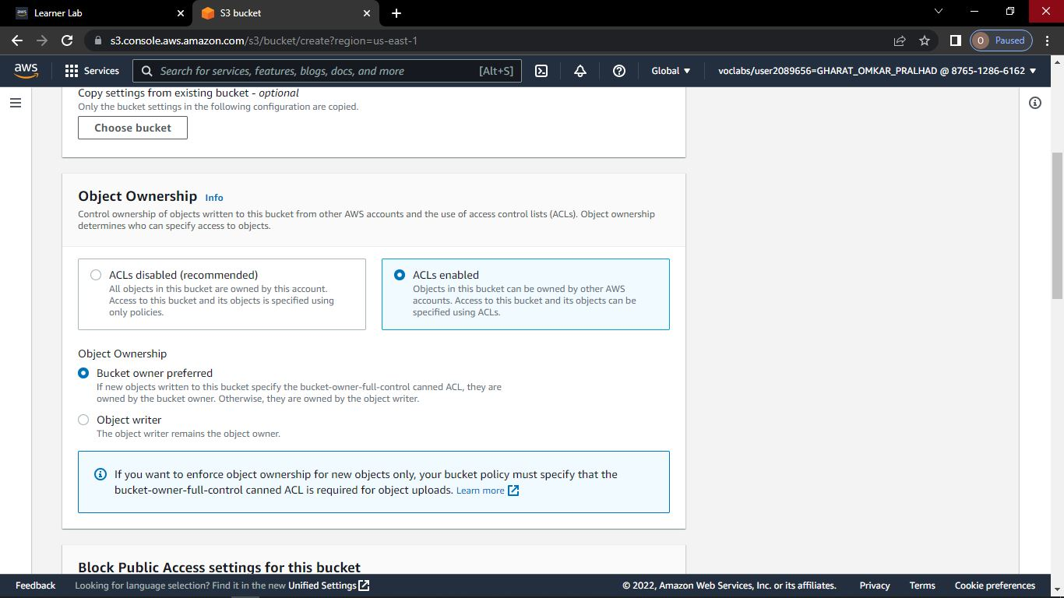

**Step-7: Click on Bucket Name**

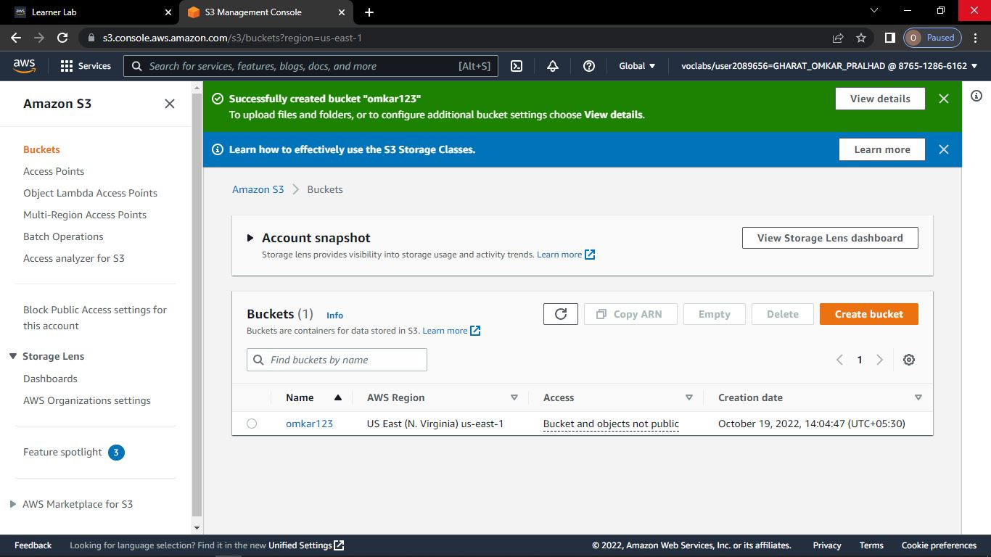

**Step-8: To Display Website**

**-> Click on Upload and upload any file**

**-> click on upload**

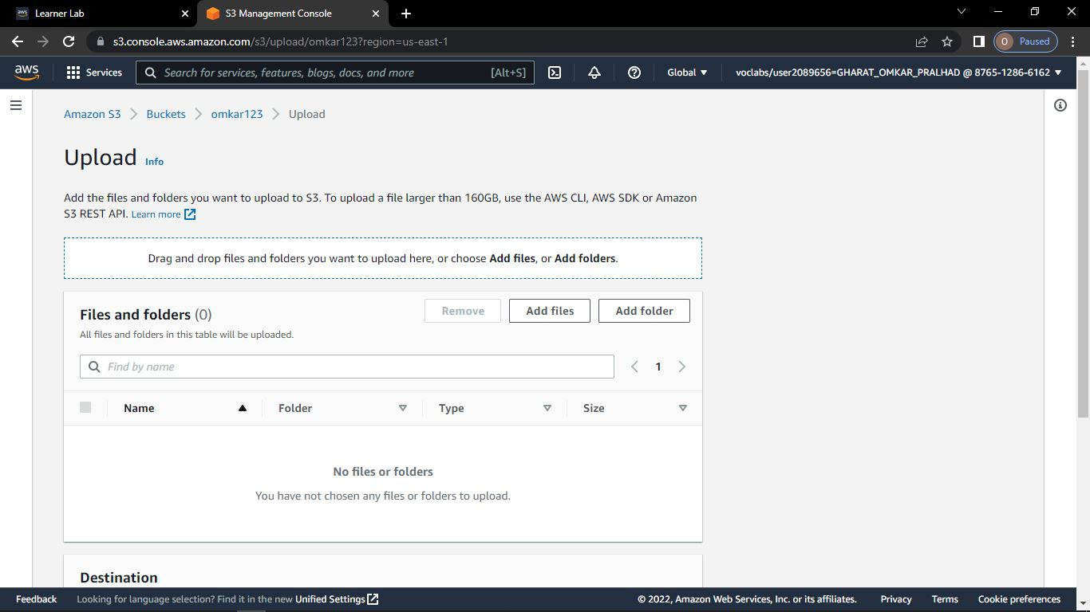

**Step-9: Click on Add files -> select any html file and click on open**

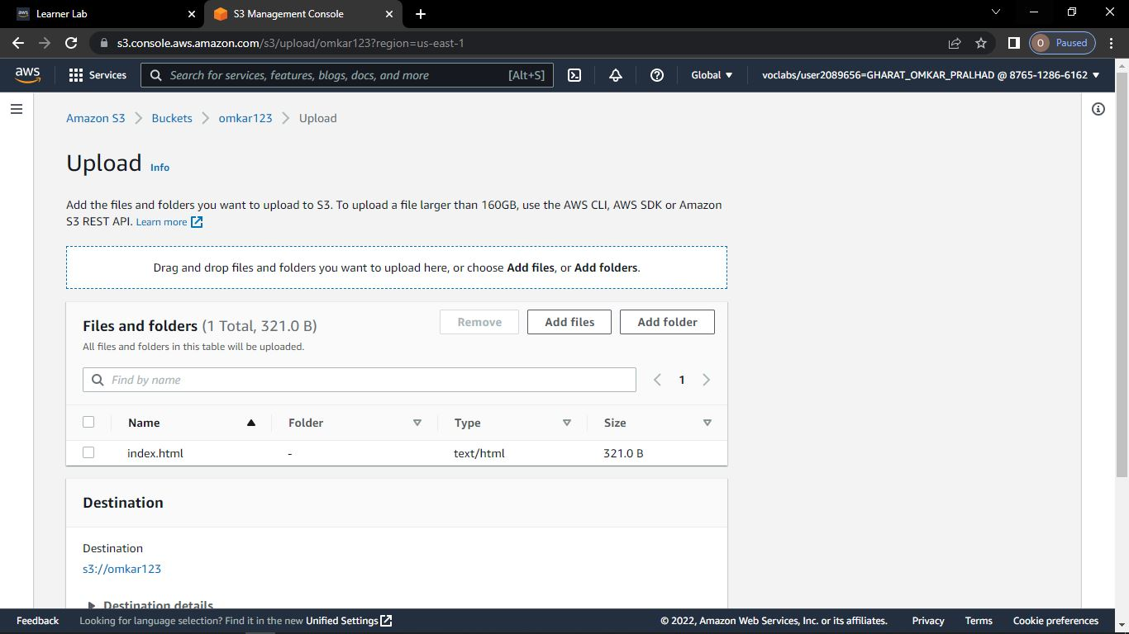

**Step-10: Click on object Name**

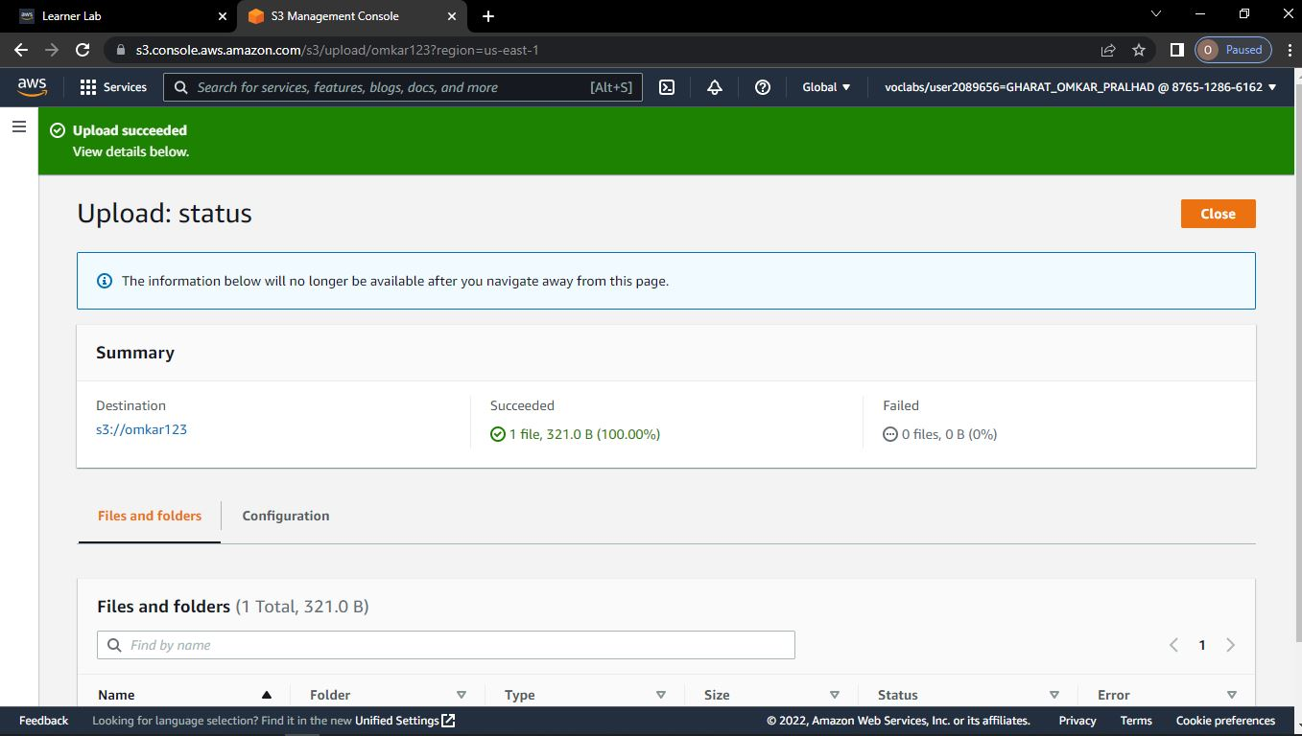

**Step-11: Go to permissions -> Click on Edit**

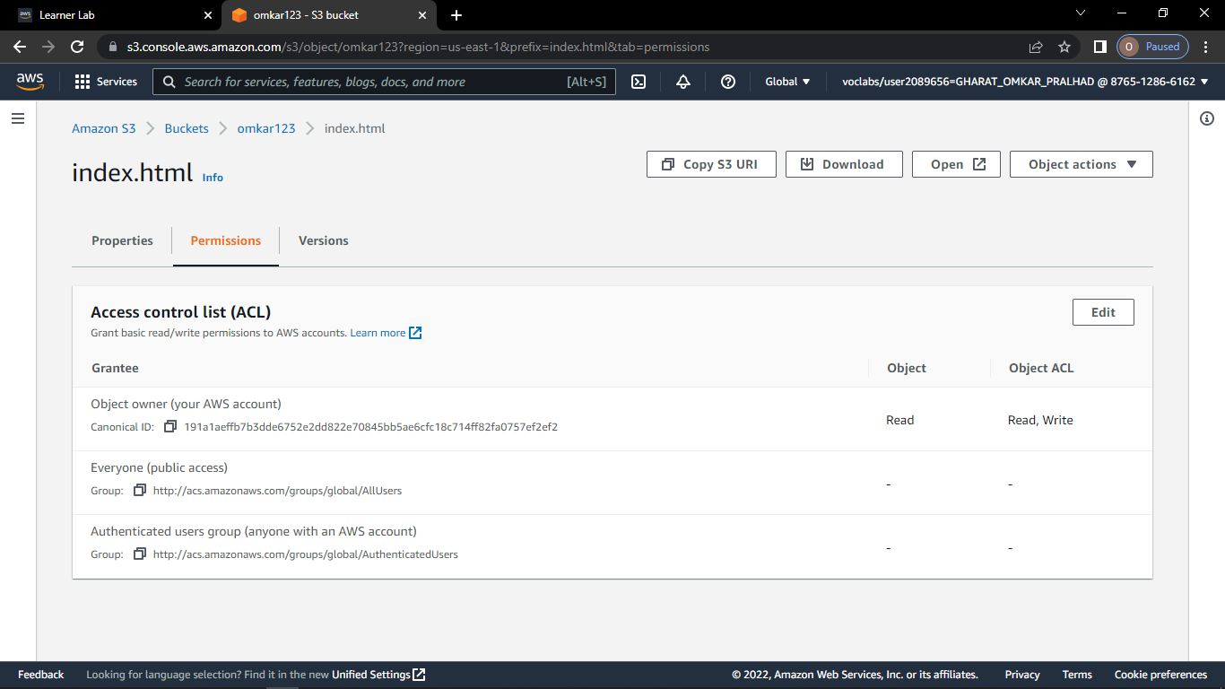

**Step-12: tick on read -> Click on save changes**

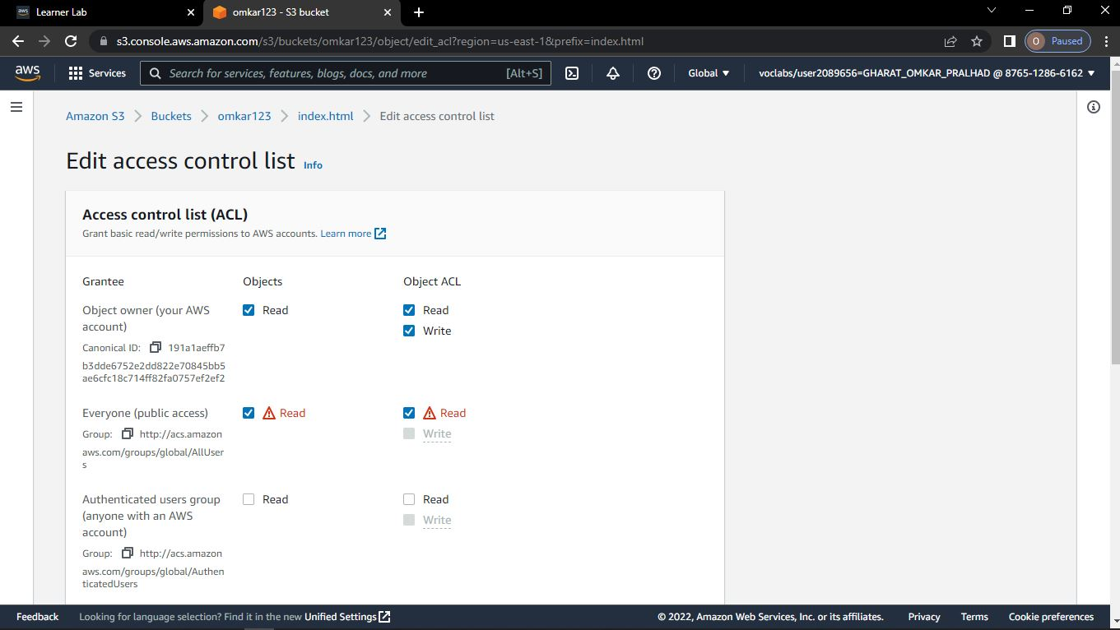

**Step-13: Go to Bucket name -> click on Object (index.html )**

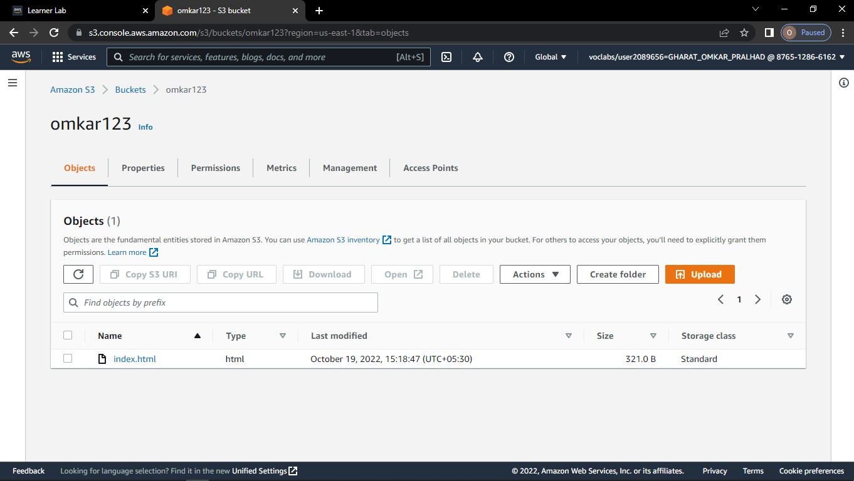

**Step-14: Go to permissions -> click on Edit**

**Step-15: tick on read -> Click on save changes**

**Step-16: Go to object -> Click on index.html**

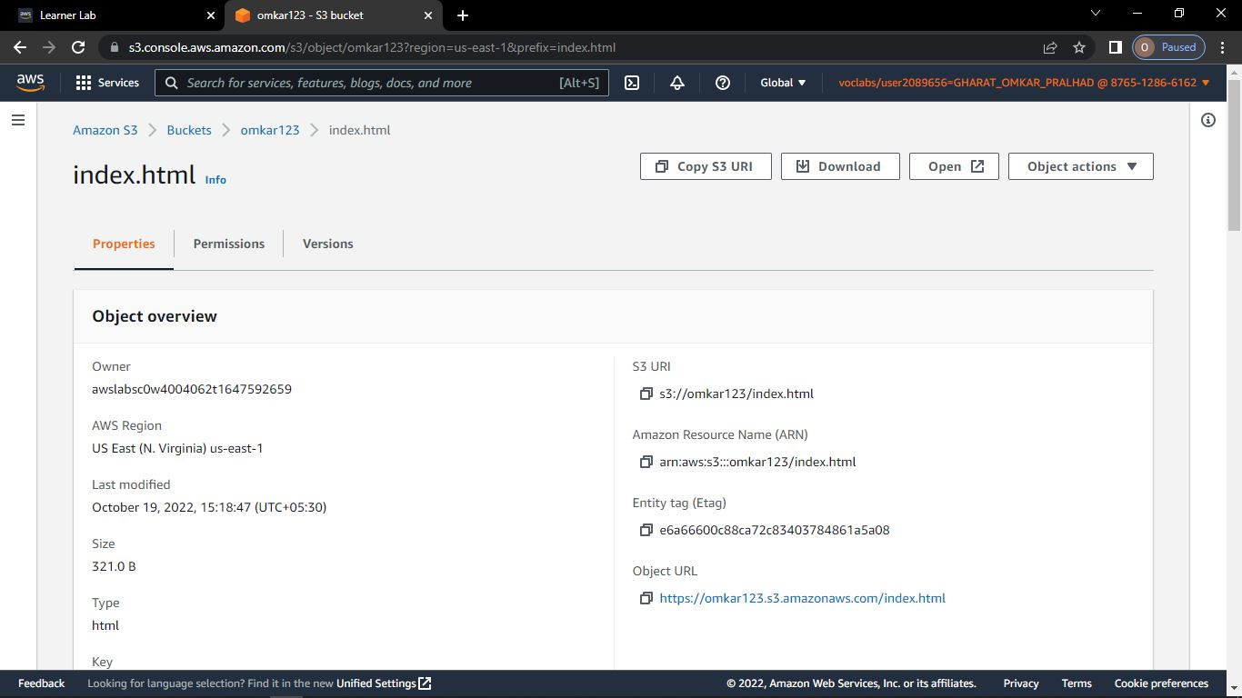

**Step-17: Click on object URL**

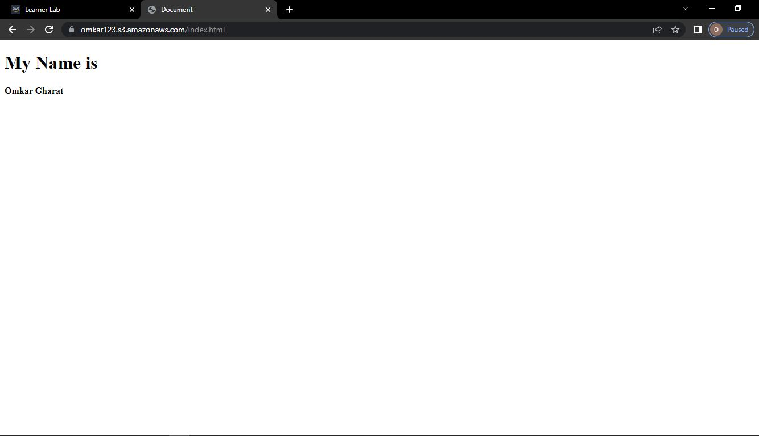

**Step-18: To Delete the object**

**Click on bucket name -> select object -> click on delete**

**Step-19: To confirm deletions -> type permanently delete -> click on delete object**

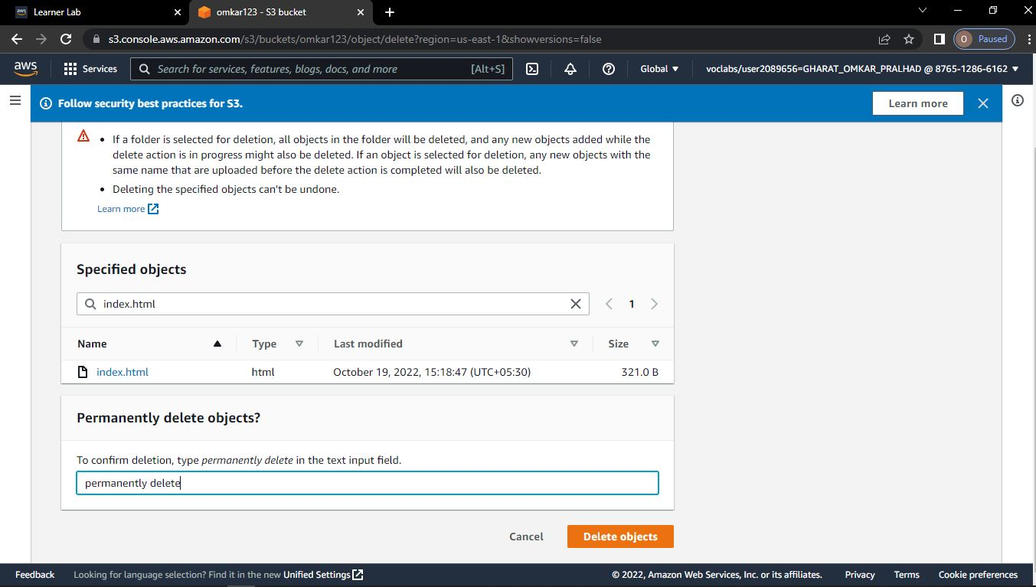

**Step-20: You have got the notification -> successfully deleted object -> click on bucket**

**Step-21: select bucket name -> click on delete**

**Step-22: To confirm deletion -> type bucket name -> click on delete bucket**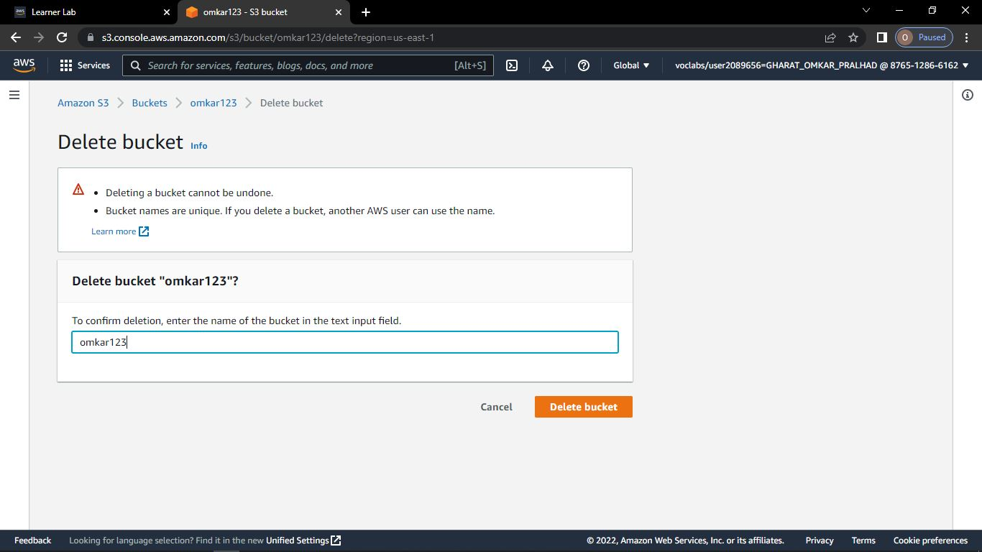

**Step-23: You have get the notification -> successfully deleted bucket**



